Screenshot of CREATE DATABASE CSD430;

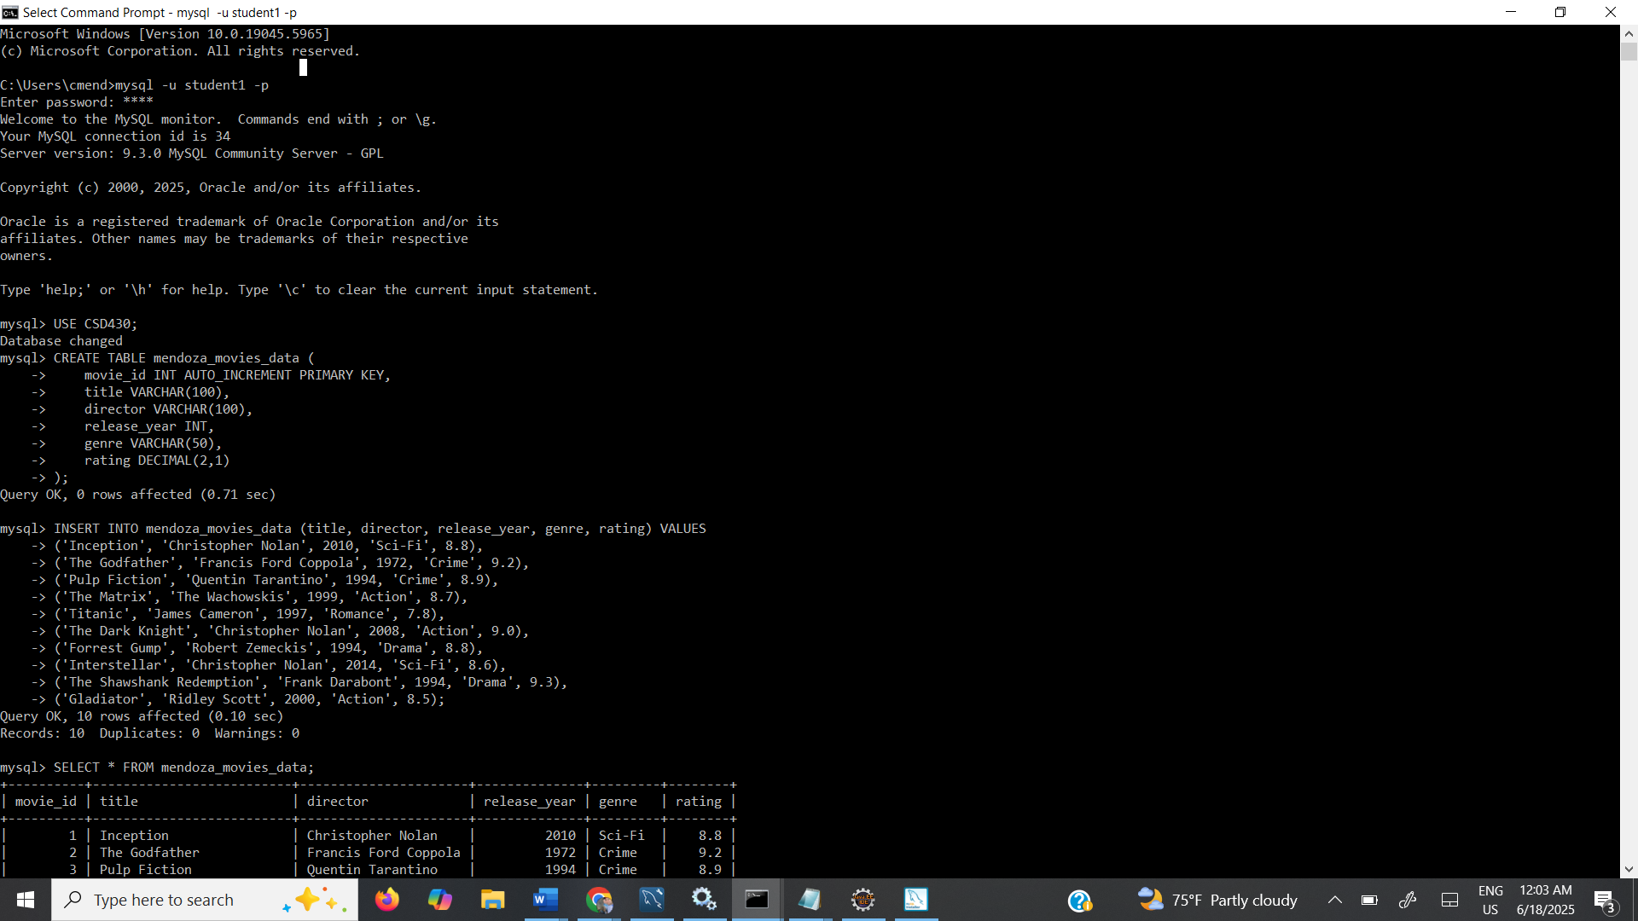

Screenshot of CREATE USER



Screenshot of CREATE TABLE

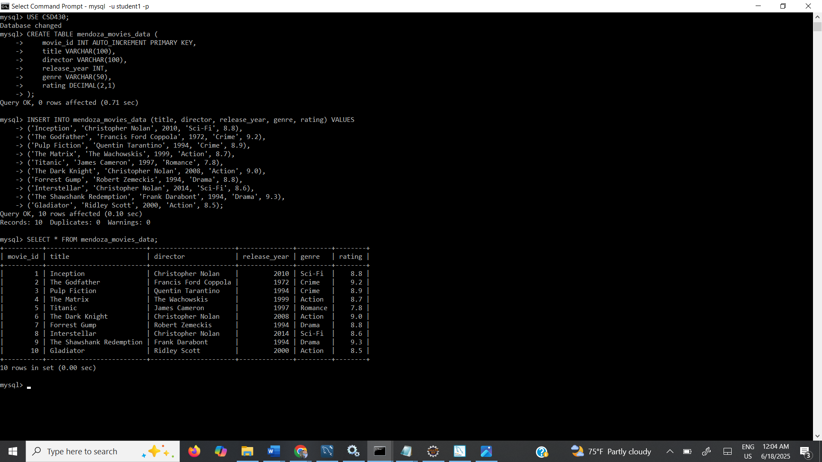

Screenshot of INSERT INTO

